Susana Rodriguez de Tembleque in conversation with Lynn Kiang

The project that Susana shared about the data visualization on the digital wall in Lincoln center was my favorite. For designers, the purpose of visualization is to visualize information through external means such as sketching, painting, icon or prototyping, so as to accurately convey its deep meaning. Strategic design often involves projects involving multiple stakeholders who have very different knowledge systems. Visualization acts as a translator, conveying logic and ideas from the designer's mind to the minds of others. I think this one is definitely successful.

“So I guess i've always asked this question when I was at my partners like do you feel like all designers are strategist inherently? Yes. Designers. I think every every piece of good design, this has a lot of strategy in it because you thought about it.” And that got me thinking. Indeed, as I learn more and more, I realize that design is not only about making things look better, but also about considering all aspects, such as practicality and so on. Design is no longer just about aesthetics, it needs to be about details and strategies, human-oriented, trying to solve problems, thinking about how to make positive, long-term changes based on the present. I like Japanese design very much. I  think Japanese designers have a very clever combination of visual aesthetics and strategy. What impressed me most was the packaging design of Japanese milk. The milk cartons are beautifully packaged with a small gap at the top for the visually impaired people to touch and identify as dairy products. At the same time, I also saw that many Japanese alcoholic drinks were marked in Braille, which greatly facilitated the daily life of this minority group. The details are done to the extreme, full of human touch.

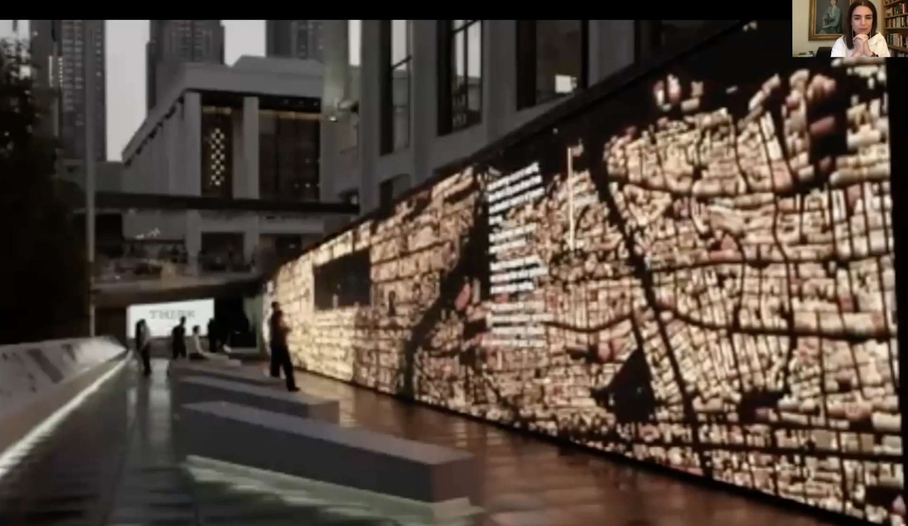

  CD Lecture Series: Jon Key

It is super cool that Jon Key is clear and consistent about his purpose of design. He has been exploring the questions he thought about in college, about his identity and his mission as a graphic designer. As a queer black designer from the South, he collaborates with many projects related to these topics. Through his design, he raise a voice for minority groups and finds his balance in various fields. I definitely support him and love what he does, but there is a slight difference between what I do and what he does. I totally understand his intention and the situation they are facing, however, I try to avoid this topics as much as possible, because I personally believe that the goal of a minority group has always been not to be "different", but seeking for the infinitely inclusiveness and to eliminate differentiation. At the same time, I have also deeply considered the issues of being a Chinese designer. For the LVMH Prize in recent years, the export of Chinese designers' creative power to Western fashion has been on the rise, and the regional label attached to Chinese designers seems to be a double-edged sword. Under the tone of respecting cultural diversity, the designer group is eager to display the breadth and depth of regional culture on a larger stage and complete cultural output. But over time, identity labels can lead to stereotyped thinking. The particularity of regional identity will attract some attention in the early stage, but when the novelty gradually flattens out, we have to explore the design ideas beyond this, create a strong impression, keep innovating around a fixed concept,  keep a global perspective, and find a balanced model. This has always been a tough issue, which requires all designers to think about.

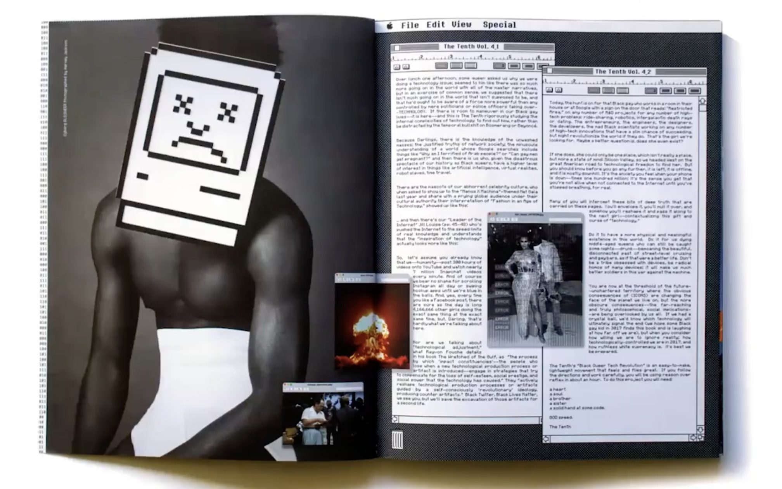

CD Lecture Series: Andrew Shurtz

In this lecture, Andrew Shurtz shares the background information and connotation of his three works, as well as his personal philosophy on design. In the lecture Andrew Shurtz mentioned that “You know, but I guess my main point is just like, look behind it. I try to see how this stuff gets made and not stress over what it is.” And Allan Hori responses him by saying :”As I know, I say, I'm not so concerned about where you end up with the end product. Like I don't care what it looks like. I'm more interested in the discussions in the process.” As they say, process plays an important role in design. In my opinion, the design process is rarely seen by others, and most of what is seen is the result. But process is the most important step for designers. A good process is actually able to decompose a big goal into logical small steps. By making each step have a clear direction, good input and output will be the basic elements that directly lead to the reasonability of the result. At the same time, a good process must be sustainable, a cycle of constant modification and innovation. When receiving feedback, be able to find the wrong step in the process and correct it immediately. In my opinion, the process of design is also a combination of sensibility and rationality, and a space for continuous self-improvement. The rational part is to judge the direction, function, and production of the work. The emotional part is the process of bringing your inspiration and imagination into the design concept. In the previous Design Studies lecture, we discussed similar issues again. As mentioned in that lecture, the maintenance of an object is also part of the result of an object, and many times maintenance is not visible. My question is, how do you make the process visible in the work, how do you know the creator's thoughts and steps.

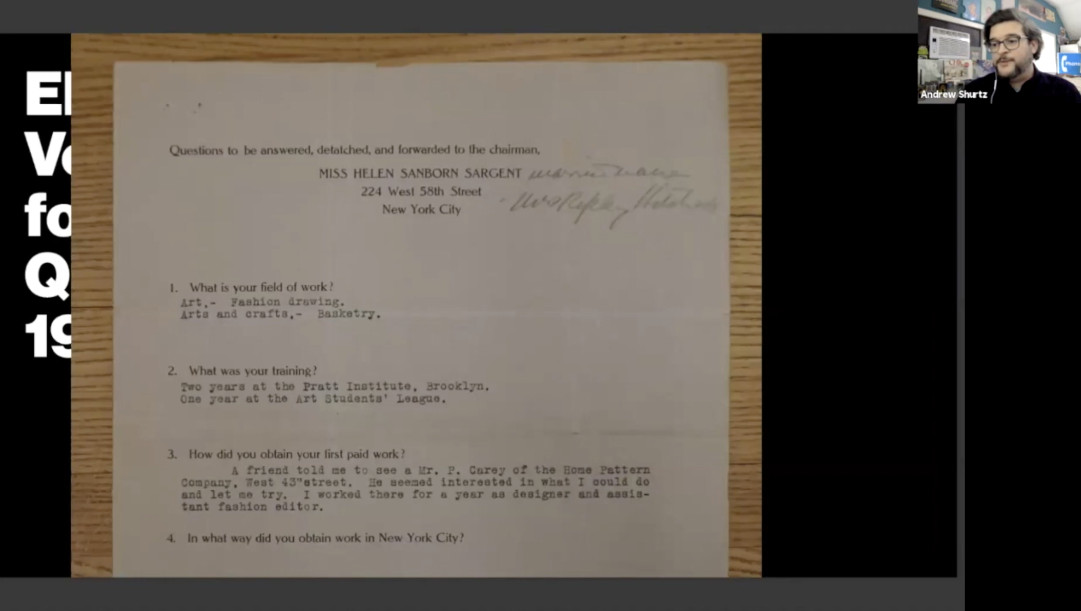

CD Lecture Series: Nikki Gonnissen in conversation with Lucille Tenazas

In this lecture, Nikki Gonnissen shew some of awesome projects that she and her group created in Amsterdam. In her project, the identity of her region is expressed and she also explains why the Dutch culture is so diverse: the Netherlands is a small country, and because of that, it is culturally diverse and inclusive. She also showed a project of cooperation with a Chinese designer, which I think is very interesting, because the thermometer model she showed in slide was also identical with the one in Shanghai that I’ve seen before. I believe they were made by the same designer.

In this complex world of globalization, each country has its own unique cultural characteristics due to a series of reasons such as history or economic development. What impresses me deeply is China or Russia and other countries with strong collectivism. The collection she collaborated with PSA is my favorite, especially when she deconstructed "当", which means contemporary, into pieces as poster elements. I think that the first barrier to a design for globalization is language, and to build a product that works on a global scale, it takes more than just translation. What really works is the combination of internationalization and localization to unify regional differences, which is exactly what her works show.

Can graphic design empower us to build a better world? As far as I am concerned, graphic design is just a medium for information presentation, is the means of combing these visual symbols and information. What matters is what you want to express and how. Making your own posters to spread on social media is one way. Making a motion graphic is another way. Making social propaganda like UI design is another way.

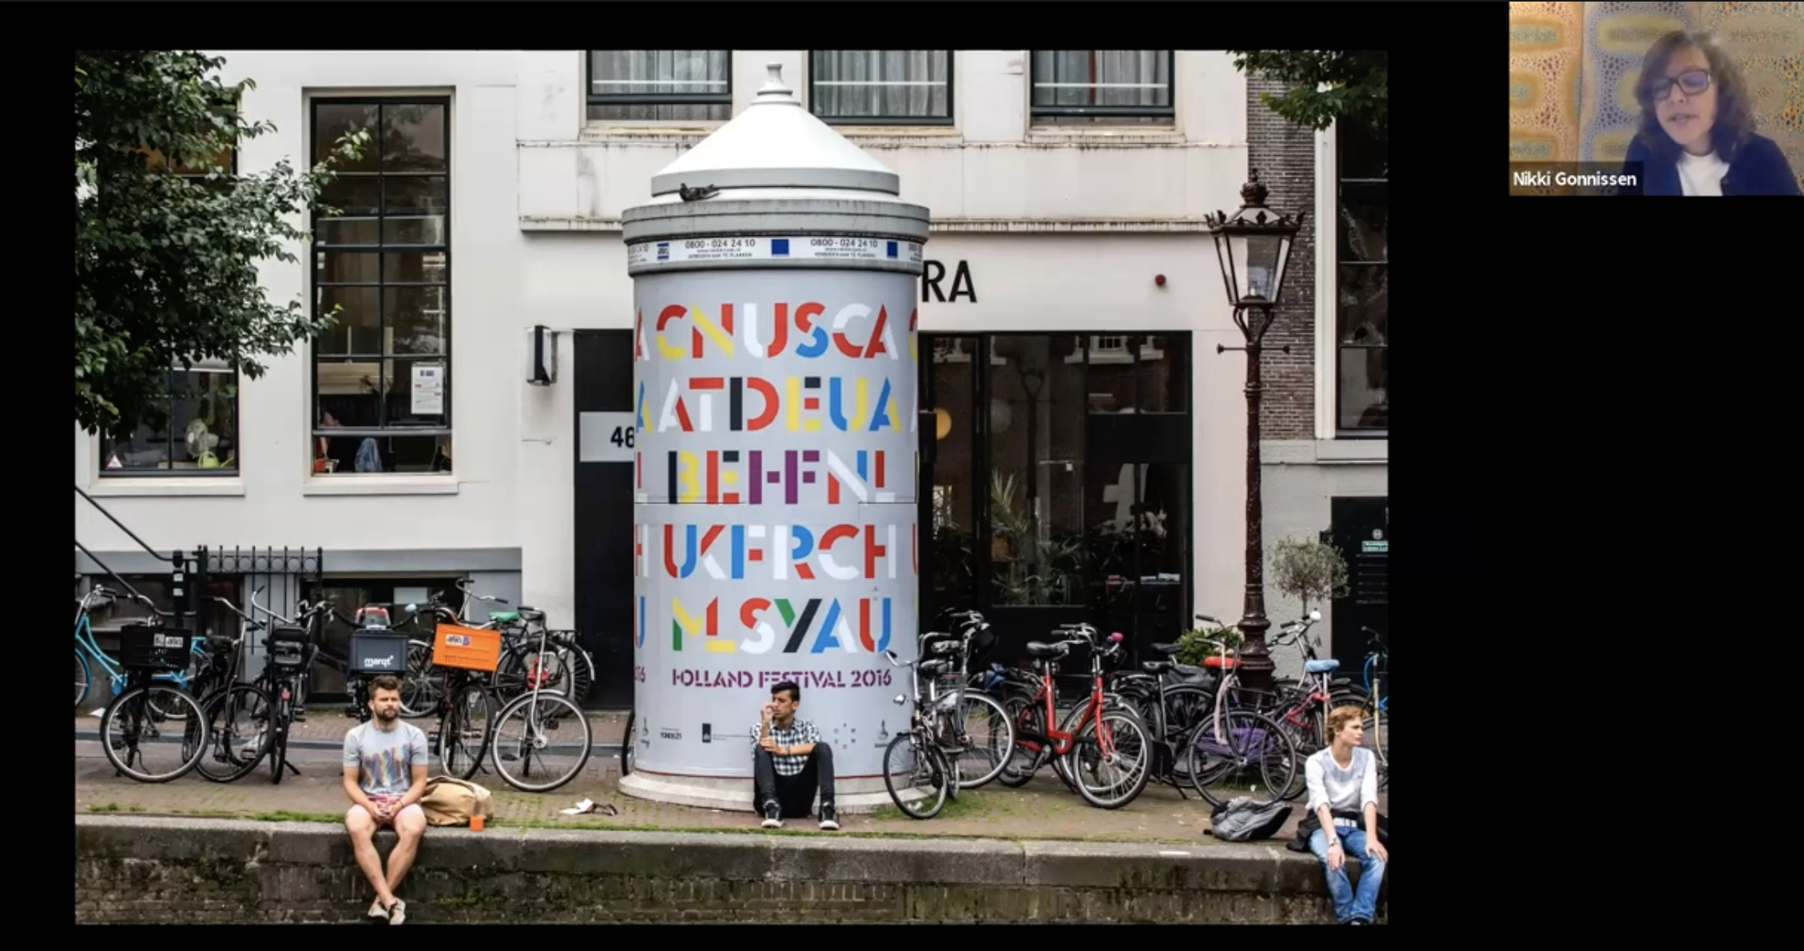

CD Lecture Series: Renda Morton

In this lecture, Renda not only showed her works, but also told a lot of stories about her from student to present. It was a tough road, but thankfully she persevered and giving me all that useful advises. I like the website design of the Art and Technology Festival very much. Although I couldn't open the website, first of all I was attracted by the patterns displayed on it. I could also see that there were many different typographic elements in it, which made the whole site look like a circuit. She said that in fact, this website does not actually allow users to clearly see Festival venue, so she decided focus on user experience more when she leaves the studio. Sometimes I am also troubled by this problem, not only the design of the website, but also for the design of posters or books. Sometimes I want to something in a more expressive way, I found it is difficult for readers or users to see the content clearly. For me, the biggest problem is how to find a balance between the two.

This lecture is very useful to me. Now I don't have much information about the future work situation, but Renda makes me know a lot about the rules of the it. It also makes me deeply understand that almost all things are negotiable. I can see from her experience that she is flexible about everything, she does a lot of reflection and tries different things. Her previous experience was very unstable. It could be said that it was a process of finding herself, but it was also a process of accumulating experience. I think from what she said, only when she has a certain cognition of herself can she find her own direction and value on the road of career. Or, as she said, you can "ask for what potential is worth".

